# Instruction

1. Install JDownloader and ProtonVPN (Windows only)
2. Test ProtonVPN and make sure it can connect to VPN
3. In JDownloader, go to Settings -> Reconnect
4. Under “Reconnect Method”, select “External Tool Reconnect”
5. Under Command, browse for the exe program
6. During downloading, make sure Auto-Reconnection is enabled  
   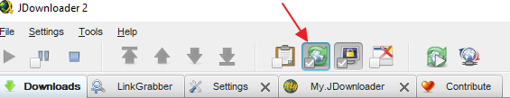
7. When JDownloader detects Mega bandwidth limit, it’ll call the script. The script basically tries to click on the ProtonVPN program to connect; at this time do not use your computer while the script is moving the mouse